Version 1.93 – 11/8/2017

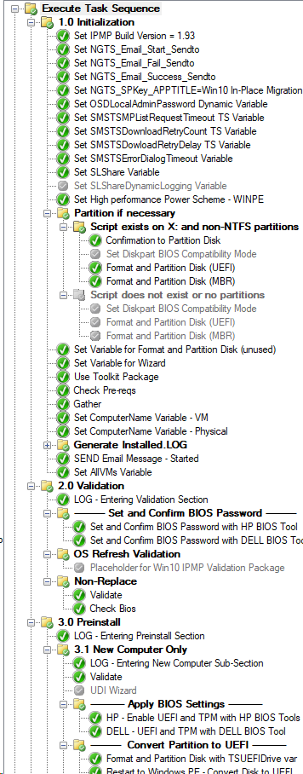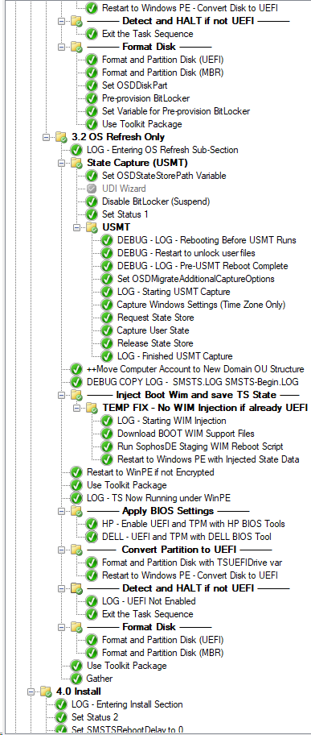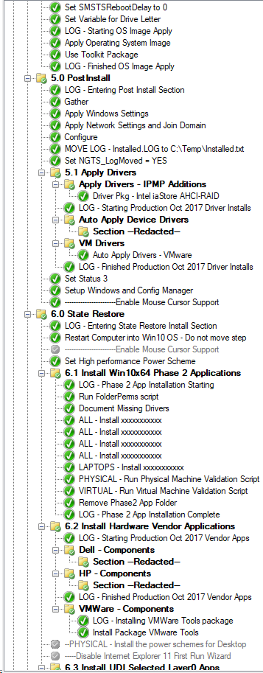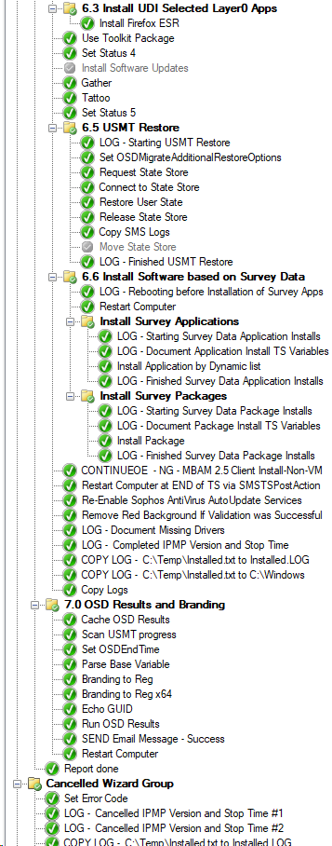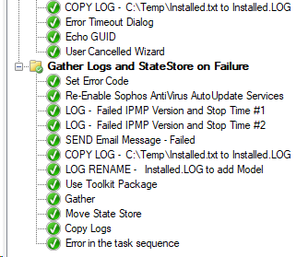

**-------- Inject Boot Wim and save TS State ------ Step with Condition**

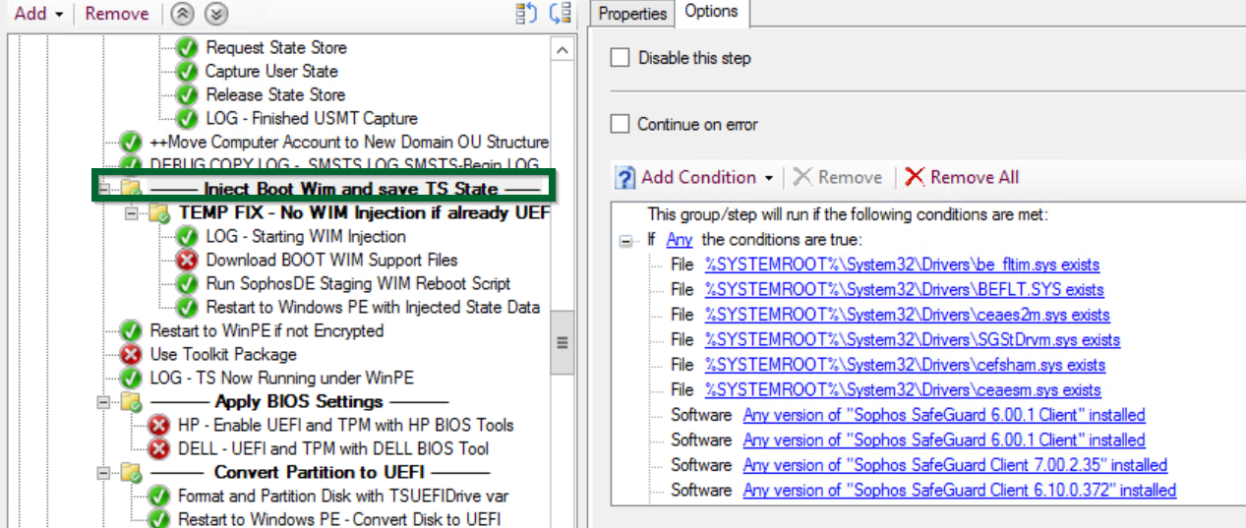

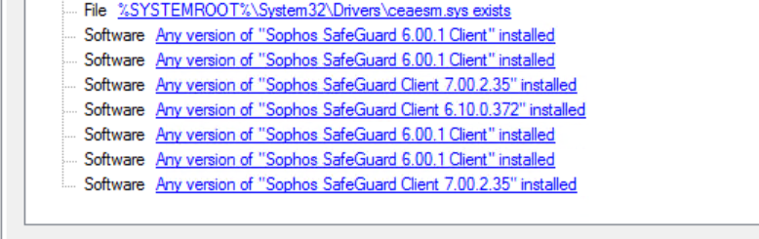

**TEMP FIX - No WIM Injection if already UEFI**

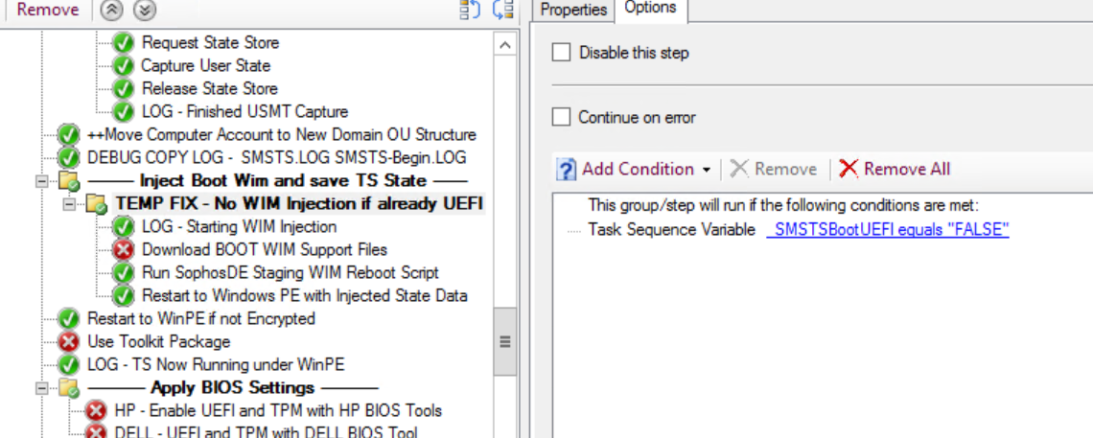

**LOG - Starting WIM Injection**

CMD.EXE /C ECHO %DATE:~-10% %TIME% Starting WIM Injection Script, downloading Boot WIM support files>> %_SMSTSLogPath%\Installed.LOG

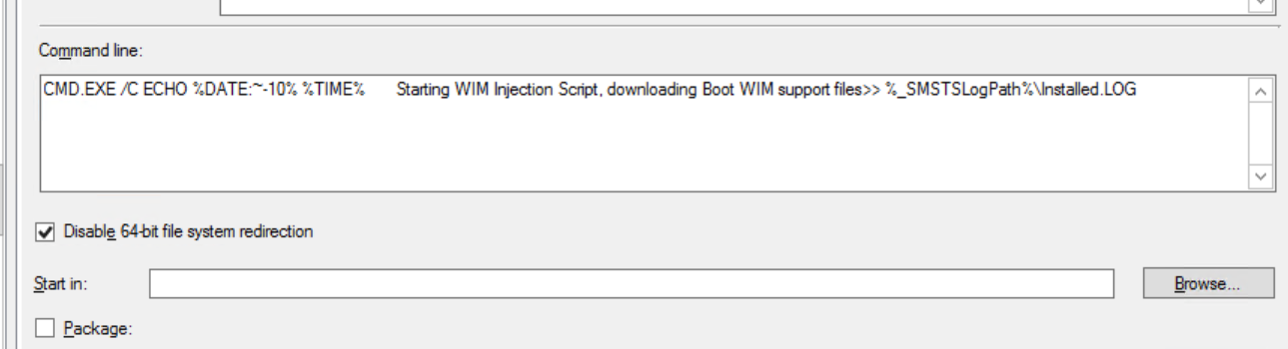

**Download BOOT WIM Support Files**

CMD /C EXIT 0

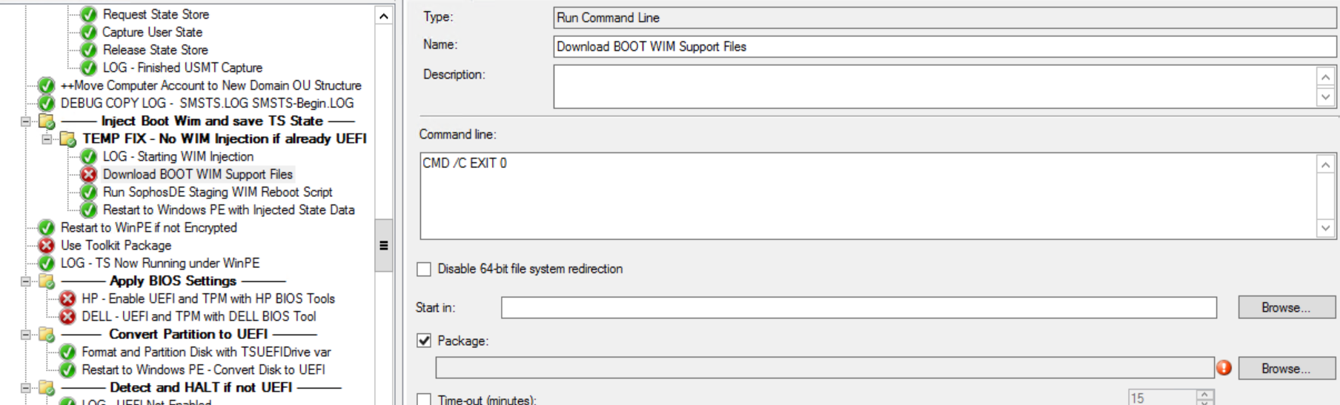

**Run SophosDE Staging WIM Reboot Script**

Description: Timeout on this step is set to 120 minutes in order to ensure that DISM commands don't timout. FYI, this script exits with a 555 if successful.

CMD.EXE /C "SET SMSLOGDIR=%_SMSTSLogPath%& SET ScriptRoot=%ScriptRoot%& SET DeployRoot=%DeployRoot%& %DEPLOYROOT%\NG_IPMP_Scripts\WIM-State-Injection\SophosDE-Phase1.cmd"

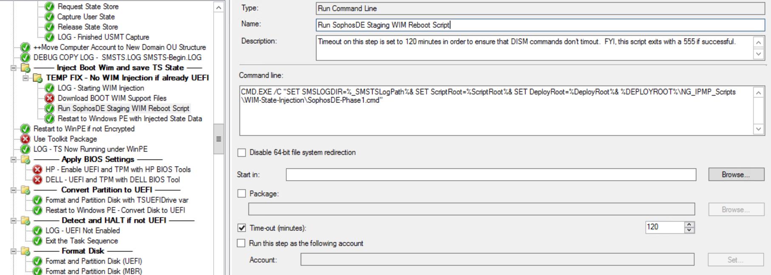

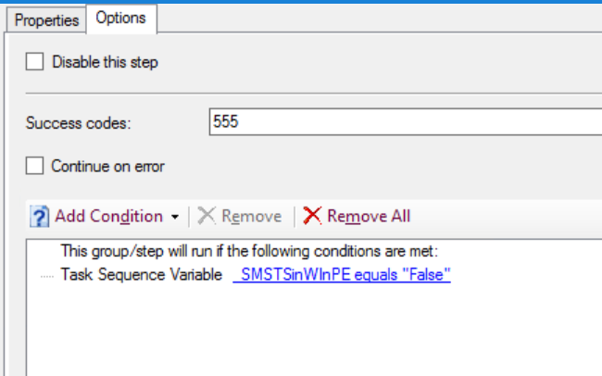

**Restart to Windows PE with Injected State Data**

